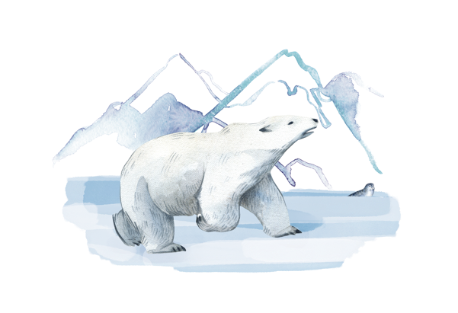

  
**Big Idea:** Organisms are interdependent

What will I be   
learning about?

**What does this mean?**

Living things are interconnected with each other, often depending on other organisms for their own survival. Plants are the basis of these relationships as they use light energy from the sun to produce food in the form of glucose through the process of photosynthesis. Animals and plants both compete for different resources.

**What is this unit about?**

In this unit you will be learning about the relationships between species in ecosystems and how these relationships are affected by human activities. You will learn about the implications of global warming on the natural world and understand how this may threaten food security for humans. You will also be learning about some of the methods that humans use to feed populations.



What should I already know?

An ecosystem is the interaction of a community of organisms with the non-living parts of their habitat

A population is a group of the same organism

A community is made of several different populations living in the same area that depend on each other for survival.

Sampling techniques are used to measure the size of a population in a habitat

Feeding relationships within a community can be represented by food chains and webs.

Producers are plants that can make their own food (glucose) using sunlight.

Primary consumers eat producers, secondary consumers eat primary consumers and tertiary consumers eat secondary consumers.

Predators are consumers that eat other animals, called prey.

In a stable community the numbers or predators and prey increase and decrease in cycles.

Food chains sometimes accumulate of toxic materials.

Trophic levels can be represented by numbers, starting at level 1 with plants and algae.

Animals often compete with each other for space, mates and food.

Plants often compete with each other for space, water, minerals and light.

Biotic factors are living things that can affect a community, such as food or predators.

Abiotic factors are non-living things that can affect a community, such as temperature, light, wind, amount of water.

The reactants of photosynthesis are carbon dioxide and water, and products are glucose and oxygen.

Human Interaction

*What effects are humans having on the environment? How does this affect different ecosystems? What can humans do to reduce their impact?*

Living things are interdependent, which means that they interact with each other for survival. This includes feeding relationships, shown in food chains and webs, and if one population is affected it can have an effect on the rest of the ecosystem. Human activities are having an impact on biodiversity on Earth, putting ecosystems at risk, but there are actions that can be taken to reduce these effects.

This is the **second** unit we are studying as part of the big idea: **Organisms are interdependent.**

In this unit we will learn about biodiversity and why it is so important for the survival of organisms, including humans. We will learn about the variety of ways that the global human population is affecting the environment; including how different types of pollution and the destruction of habitats is reducing biodiversity. We will also learn different approaches being used across the globe to prevent this decrease in biodiversity and consider how indicator species can be used to monitor environmental pollution.

We will learn how the efficiency of energy transfer decreases throughout a food chain and how that applies to pyramids of biomass. We will use this to consider why reducing meat intake is a sustainable choice. Finally we will look at why food security is so threatened, and how it can be enhanced through the use of initiatives and the development of new technologies. We will also develop our knowledge and skills of sampling techniques, and understand why evidence is so important when proposing a scientific theory.

TASKS:  
What subject will this unit focus on? (circle the correct subject)

BIOLOGY CHEMISTRY PHYSICS

There are lots of keywords underlined above. List these into the two columns:

|  |  |
| --- | --- |
| Words I know | Words I haven’t seen before |
|  |  |

To answer before the unit:

1. What are you most excited to learn about in this topic?

________________________________________________________________________

________________________________________________________________________

________________________________________________________________________

1. What do you already know about this topic?

________________________________________________________________________

________________________________________________________________________

________________________________________________________________________

1. Why do you think it’s important to learn that cells are alive?

________________________________________________________________________

________________________________________________________________________

________________________________________________________________________

1. What knowledge from previous science lessons might help us?

________________________________________________________________________

________________________________________________________________________

________________________________________________________________________

1. What questions do you have about this topic?

________________________________________________________________________

________________________________________________________________________

________________________________________________________________________

To answer at the end of the unit:

1. Tick off any words in the ‘words I haven’t seen before’ column that you are now confident with. Circle any you still need more practice to use.
2. What have you most enjoyed about this unit?

______________________________________________________________________

______________________________________________________________________

______________________________________________________________________

1. What more would you like to learn about as part of the big idea: ‘cells are alive’?

______________________________________________________________________

______________________________________________________________________

****This multiple choice assessment will check that you are ready to start learning about this unit. Take this quiz without any help.

Pre-Test

When you’ve finished, check the answers on the next page and complete any ‘fix-it’ tasks before moving on to learn the new topic.

1. Which is the best definition of an ecosystem?

A. The place where an organism lives

B. The interaction of a community of organisms with the non-living parts of their habitat

C. The relationships between animals that can be represented using a food chain

2. What resources do animals compete for?

A. Light, water and space

B. Space, mates and food

C. Food and water

3. Which of these is always the first organism or stage in a food chain?

A. Producer

B. Consumer

C. Herbivore

4. What do plants need in order to be able to photosynthesise?

A. Light and water

B. Oxygen and glucose

C. Light, water and carbon dioxide

5. Which is the correct definition of a population?

A. A group of organisms of the same species

B. A group of animals in a specific habitat

C. A group of different species in the same habitat

6. Which of these is a biotic factor?

A. Temperature

B. Food availability

C. Water availability

7. Which method of sampling would be used to estimate the number of plants in a field?

A. Random sampling

B. Systematic sampling

C. Using a quadrat

Use the following food web to help you answer Q8-10.

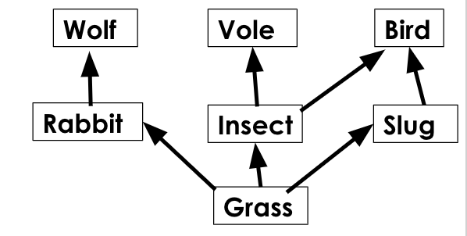

8. Which term could be used to describe the rabbit?

A. Secondary consumer

B. Predator

C. Herbivore

9. Which of these species could be described as a primary consumer?

A. Wolf

B. Grass

C. Slug

10. A new disease has affected the rabbit population. Which of these could  
be a consequence of this?

A. The population of wolves would increase

B. The population of wolves would decrease

C. The amount of grass would decrease

End of Unit Pre-Test. Turn over to see the answers. Give yourself a mark out of 10.



Great job! Now you’re ready to start learning about human interaction!

Pre-Test Answers

|  |  |  |
| --- | --- | --- |
| Question | Answer | What to do next (Fix-It task) |
| 1 | B | If you answered A or C you need to review the meanings of ecosystem and habitat. State the definitions of the following terms: organism, population, community, habitat, ecosystem. |
| 2 | B | If you answered A or C you need to review the resources that plants and animals compete for. Explain why animals compete for mates and territory and compare the resources that plants and animals compete for. |
| 3 | A | If you answered B or C you need to review where animals get their energy from. Explain where plants get their energy from and where animals get their energy from. |
| 4 | C | If you answered A or B you need to review the chemical equation for photosynthesis. Write the photosynthesis word equation and describe where plants get each of the raw materials from. |
| 5 | A | If you answered B or C you need to review the meaning of the terms population and community. Give an example of a population, a community and a habitat within a desert ecosystem. |
| 6 | B | If you answered A or C you need to review the difference between biotic and abiotic factors. State the definition and give two examples of each. |
| 7 | A | If you answered B or C you need to review the different methods of sampling and when they are used. Describe the method of sampling you would use when investigating the effect of light intensity on the growth of grass. |
| 8 | C | If you answered A or B you need to review the difference between a primary and secondary consumer. State the definitions of the following terms: herbivore, carnivore, omnivore, producer, consumer. |
| 9 | C | If you answered A or B you need to review the levels of a food chain. Put these species into a food chain: shark, plankton, seal, herring. |
| 10 | B | If you answered A or C you need to review the interactions of species in a food chain. Explain why the population of wolves would decrease if there was a decrease in the population of rabbits. |



Knowledge  
Organiser

Biodiversity

1. Biodiversity is the **variety** of different species in an **ecosystem**
2. Biodiversity can be measured by using **sampling** techniques to count the **abundance** of different species
3. A quadrat is a piece of equipment (a frame) used to count the abundance of species
4. 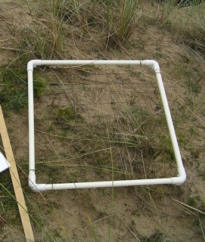**Random** sampling is used to measure the abundance of a species in a particular habitat, using quadrats placed at random coordinates
5. **Systematic** sampling is used to measure the effect of a factor on the distribution of a species, using a **transect** with quadrats placed at regular intervals
6. High biodiversity makes an ecosystem **stable** because each species is not dependent on just one other

How Humans affect Biodiversity

1. Many human activities are **reducing biodiversity** on Earth
2. The global population is increasing, so more resources are needed and more **waste** is being produced
3. Pollution is caused when waste is not properly treated
4. Pollution can be very harmful to plants and animals and **reduce biodiversity**
5. Pollution does not always affect all species equally, as some may be more resistant
6. **Biodiversity** is reduced by humans using land for building, quarrying, farming and waste disposal
7. **Peat** from peat bogs is used for compost for gardens and farms, destroying habitats
8. Scientists and other citizens are using different methods to **counteract** some of the negative impacts of humans on biodiversity:
   * Protecting rare **habitats**
   * Maintaining **nature reserves**
   * **Breeding** programmes for endangered species
   * **Recycling** resources to reduce landfill waste
   * Reducing deforestation
   * Growing **hedgerows** on farms to allow more crops to grow

Global Warming

1. Levels of carbon dioxide and methane (**greenhouse gases**) in the atmosphere are increasing, contributing to global warming
2. Human activities contribute to greenhouse gas **emissions**, particularly the burning of **fossil fuels** in industry and transport
3. There are many **biological** **consequences** to global warming including:
   * Melting polar ice caps
   * Rising sea levels
   * Extreme weather patterns
   * Flooding
   * Loss of habitats

Human Waste

1. The increasing human **population** means that more resources are required and more waste is produced
2. More waste is also produced through the improved standard of living
3. If waste is not treated properly it results in pollution:
   * **Water pollution** is caused by poor sewage treatment and leaching of fertilisers
   * **Air pollution** is caused by smoke and acidic gases
   * **Land pollution** is caused by landfill and toxic chemical waste

Pyramids of Biomass

1. Biomass is **lost** between **trophic levels** in a food chain
2. 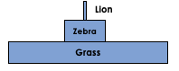Producers (mostly plants and algae) transfer about 1% of the light energy they absorb for photosynthesis
3. Only approximately **10%** of biomass from each trophic level is **transferred** to the level above
4. Biomass is **lost** through waste (faeces, urine, sweat, gas) and through life processes such as **movement** and **thermoregulation.**

Farming and Biotechnology

1. **Efficiency** of food production (between trophic levels) can be improved by **restricting** energy transfer from food animals to the environment
2. This includes **intensive** farming methods where movement of animals is limited and the temperature of their surroundings is controlled
3. Fish stocks in oceans are declining because of overfishing
4. Fish stocks need to remain at a high enough level for breeding to occur, to prevent the disappearance of some species
5. Fishing **quotas** are used to ensure that ocean fish stocks remain at a sufficient level and **net sizes** can be restricted to prevent juvenile fish being caught, so they can then have their own offspring
6. Modern **biotechnology** allows large quantities of **microorganisms** to be cultured for food
7. ***Fusarium*** fungus is used to produce mycoprotein (Quorn), a protein-rich food suitable for vegetarians
8. Fusarium is grown on glucose syrup in aerobic conditions before being harvested and purified
9. Genetically modified (GM) bacterium can be used to produce **insulin** to be harvested and purified to treat people with diabetes
10. **GM crops**, such as golden rice, can be used to provide increased nutritional value in areas where it is lacking

Food Security

1. Food security is having **enough food** to feed a **population**
2. Many factors can threaten food security:
   * Increasing **birth rate** means there is not enough food for the growing population
   * **Changing diets** in developed countries means that scarce food resources are being transported across the world
   * New **pests** and pathogens are affecting farming
   * Environmental changes, including **droughts**, which can lead to **famines**
   * Political instability and **conflicts** in some parts of the world threaten access to food and water
3. **Sustainable** methods must be found and used to feed Earth’s population



Glossary

**Abundance** The quantity or amount of something present in a particular area.

*The ecologist sampled the field to estimate the* ***abundance*** *of daisy plants present.*

**Biodiversity** The variety of all the different species in an ecosystem or area.

*A stable ecosystem has a high* ***biodiversity.***

**Biomass** A measure of the total quantity of biological material in one or many organisms.

*The total* ***biomass*** *of all the grass plants in the field is 10000 kg.*

**Biotechnology** The use of biological processes for industrial or medical purposes.

*Genetic modification of bacteria to produce human insulin is an example of* ***biotechnology.***

**Carnivore** An animal that only feeds on other animals.

*A lion is an example of a* ***carnivore.***

**Climate Change** The overall change in weather patterns (global or regional) over a long period of time.

*Many countries have reported more extreme weather thought to be due to* ***climate change.***

**Consumer** Organisms that cannot make their own food, so must eat other organisms.

*All animals are* ***consumers*** *because they cannot make their own food.*

**Contamination** Making something impure by polluting or poisoning.

*Sewage water must be treated properly otherwise there is a risk of* ***contamination*** *to rivers and seas.*

**Deforestation** When humans cut down wide areas of trees.

***Deforestation*** *is happening around the world to make space for farming.*

**Ecosystem** The interaction of a community of organisms with the non-living (abiotic) parts of their habitat.

*A rainforest* ***ecosystem*** *contains gorillas, ants, nut trees, water and sunlight.*

**Efficiency** The proportion of something which is useful vs wasted.

*The* ***efficiency*** *of biomass transfers from one trophic level to another is around 10%.*

**Emissions** The release of greenhouse gases.

*Increased carbon dioxide* ***emissions*** *are linked to global warming.*

**Energy Transfer** Energy is moved between trophic levels when one organism eats another organism.

*The first* ***energy transfer*** *in a food chain happens when a consumer eats a producer.*

**Eutrophication** Excessive nutrients in a body of water which cause excessive plant growth.

*Fertilisers running from fields into rivers and streams can cause* ***eutrophication****.*

**Famine** An extreme shortage of food.

*Decreased food security may lead to* ***famine****.*

**Fertiliser** A chemical added to soil to increase the mineral content which improves plant growth.

*Farmers add* ***fertilisers*** *to the soil every year to help their crops grow.*

**Food Security** Having enough food to feed a population.

*Increased birth rates is a factor that can threaten the* ***food security*** *of a country.*

**Global Warming** The rise in global temperatures due to greenhouse gases.

*Burning fossil fuels is a big contributor to* ***global warming.***

**Greenhouse Gas** A gas that contributes to the greenhouse effect and global warming.

*Carbon dioxide and methane are both examples of* ***greenhouse gases.***

**Habitat** The area where an organism lives.

*The* ***habitat*** *of a polar bear is sea ice.*

**Herbivore** An animal that eats only plants.

*A rabbit is an example of a* ***herbivore.***

**Indicator Species** Organisms that can tell us about the levels of pollution in an area by their presence or absence.

*Lichen are an* ***indicator species*** *for air pollution.*

**Intensive Farming** A process that uses machines, fertilisers and man-power to maximise food production.

***Intensive farming*** *methods have been used because there is high demand for cheap meat and animal products.*

**Leaching** Movement of minerals through soil often due to rainwater.

***Leaching*** *of minerals from famers’ fields can lead to eutrophication of surrounding bodies of water.*

**Peat** A dark brown substance, like soil, that is formed when plant material cannot decay because of acidic and anaerobic conditions.

***Peat*** *can be burned as fuel or used as compost by gardeners and farmers.*

**Pollution** Caused when human waste isn’t properly handled or disposed of.

*Water* ***pollution*** *can come from untreated sewage or from fertilisers.*

**Predator** Consumers that eat other animals.

*A fox is the* ***predator*** *of a rabbit.*

**Prey** Animals that are eaten by other animals.

*A rabbit is the* ***prey*** *of a fox.*

**Producer** Organisms that can make their own food using photosynthesis.

*Plants and algae are examples of* ***producers.***

**Quadrat** A piece of equipment used to count the number of organisms/individuals in a specific area.

***Quadrats*** *are used during both random and systematic sampling to count the individuals in an area.*

**Quota** A limited quantity of something.

*Countries have fishing* ***quotas*** *meaning there is a limited number of fish they are allowed to catch.*

**Resources** A substance or object required by an organism for normal growth, maintenance and/or reproduction.

***Resources*** *that plants need to live are space, water, sunlight and minerals.*

**Sewage** Wastewater that is produced from human households and industries.

***Sewage*** *water needs to be treated so that it does not pollute rivers and seas.*

**Species** A group of similar organisms that breed together to produce fertile offspring.

*Lions and tigers are different* ***species*** *because when they breed together their offspring are not fertile.*

**Thermoregulation** The process where an animal uses energy to maintain a constant body temperature.

*Humans need to use energy to* ***thermoregulate*** *and keep their internal body temperature at approximately 37oC.*

**Transect** A line placed across a habitat for systematic sampling.

*The ecologist used a* ***transect*** *to investigate how the presence of a lake affected the distribution of frogs.*

**Trophic Level** An organism’s position in a food chain.

*A producer is always found at the first* ***trophic level*** *as they are at the beginning of a food chain.*

Do Now:

**Fox**

New Learning

Prior Knowledge Review

1. State the producer in this food chain.

___________________________________________________________

1. State which species is the secondary consumer.

**Rabbit**

___________________________________________________________

1. State which species is a predator and which is prey.

___________________________________________________________

**Grass**

1. State the process by which producers make their own food.

________________________________________________________________________

1. How are herbivores and carnivores different?

________________________________________________________________________

**Foundation:** Explain the difference between a producer and a consumer.

________________________________________________________________________

**Stretch:** Describe what would happen if the rabbits are died of a disease.

________________________________________________________________________

________________________________________________________________________

1. State the correct word for each definition.

Activities

and Practice

1. A consumer that only eats plants and algae
2. The place where an organism lives
3. A carnivore with no predators (at the top of the food chain)
4. A diagram that shows multiple food chains
5. An organism that makes glucose through photosynthesis
6. An organism that eats both plants and other animals
7. 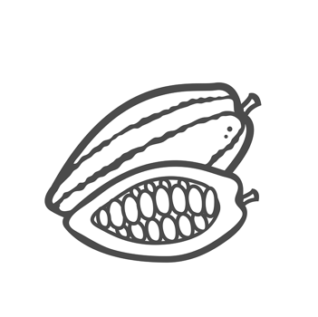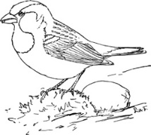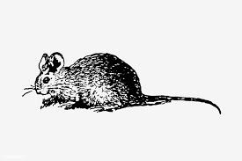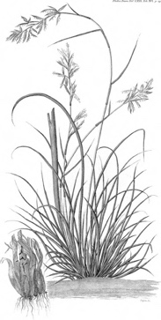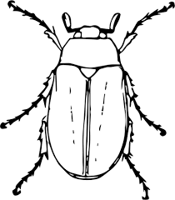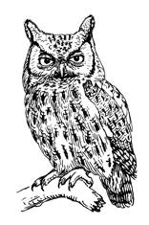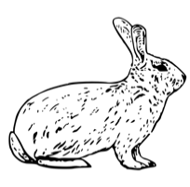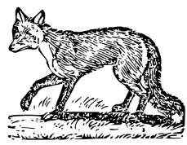Use the following food web to answer the questions:

Grass

Lettuce

Fox

Rabbit

Seeds

Owl

Mouse

Beetle

Sparrow

Identify any **producers** (circle the name of the species in **green**).

Identify any **primary consumers** (circle the name of the species in **blue**).

Identify any **secondary consumers** (circle the name of the species in **black**).

Identify any **predators** (put a black dot next to the name of the species).

Identify any **prey** (put a blue dot next to the name of the species).

Determine which species are **herbivores** (draw a square around the name of the species).

Determine which species are **carnivores** (draw a triangle around the name of the species).

1. Describe what would happen if the population of ­­­­­­­­rabbits was suddenly reduced.

_____________________________________________________________________

_____________________________________________________________________

_____________________________________________________________________

_____________________________________________________________________

1. Describe the effects of introducing a new species of sparrow into this food web.

_____________________________________________________________________

_____________________________________________________________________

_____________________________________________________________________

_____________________________________________________________________

1. Explain what the arrows represent in a food chain or a food web.

_____________________________________________________________________

_____________________________________________________________________

1. Plants and animals compete with each other for a number of resources.
   * + 1. State the resources that animals compete for.

_____________________________________________________________________

_____________________________________________________________________

* + - 1. State the resources that animals compete for.

_____________________________________________________________________

_____________________________________________________________________

* + - 1. Explain the difference between biotic and abiotic factors.

_____________________________________________________________________

_____________________________________________________________________

_____________________________________________________________________

_____________________________________________________________________

* + - 1. Classify all factors from Q3a and 3b as biotic or abiotic factors.

**Stretch** **activity:** Some students are researching the biodiversity of a field that contains a large oak tree. They have hypothesised that there will be fewer plants growing in the area around the tree than anywhere else in the field. Suggest a method for them to test their hypothesis and suggest a reason for their hypothesis.

1. Which best explains what the arrows on a food chain or web represent?

Exit Ticket

A. Which animals are being eaten

B. The direction of energy transfer

C. Producers, primary consumers and secondary consumers

2. A primary consumer is…

A. A carnivore that only eats plants

B. A herbivore that eats other animals

C. A herbivore that eats plants or algae

3. What is the correct definition of a habitat?

A. The interaction between a community and the non-living parts of their environment

B. The place where an organism lives

C. Forest, ocean or desert

For question 3, read the guidance below and carry out the ‘fix-it’ task which has been set for you.

If you answered A

Human activities such as deforestation contribute to the loss of habitats. A habitat is the place where an organism lives. The interaction between a community and the non-living parts of their environment (their habitat) is an ecosystem.

*Explain the difference between a habitat and an ecosystem and give an example of each from the forest.*

If you answered B

Human activities such as deforestation contribute to the loss of habitats. A habitat is the place where an organism lives. Different organisms have different features and adaptations that make them suited to their habitats.

*Explain why deforestation has an effect on habitats.*

If you answered C

Human activities such as deforestation contribute to the loss of habitats. A habitat is the place where an organism lives. Forest, ocean or desert are all examples of specific habitats, rather than the definition of one.

*Describe your habitat.*

Do Now:

New Learning

Biodiversity

1. State the definition of an organism.

________________________________________________________________________

1. State the definition of a population.

________________________________________________________________________

1. State the resources that plants compete for.

________________________________________________________________________

1. Describe where producers are always found in food chains or webs.

________________________________________________________________________

1. Calculate the mean of the following numbers: 12, 15, 18, 11, 24

________________________________________________________________________

**Foundation:** Explain the difference between predators and prey.

________________________________________________________________________

________________________________________________________________________

**Stretch:** Compare the resources that plants and animals compete for and explain why they are not the same.

________________________________________________________________________

________________________________________________________________________

**Biodiversity** is the **variety** of all the different **species** in an ecosystem

This includes all the **genetic** variation (differences) within a species.

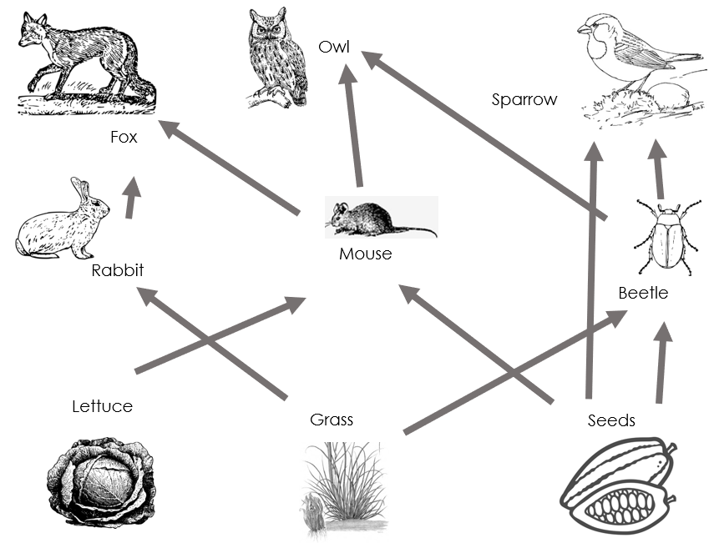**High** biodiversity is a good thing because it means that an ecosystem is **stable**, and that each organism in the food web has different feeding possibilities. This means that each species is not **dependent** on one other species. If there is low biodiversity, it means there are not as many species present, which is likely to be a bigger risk if the food supply is affected.

Biodiversity of an area or habitat can be measured using **sampling** techniques. A sample is a small thing or selection that is **representative** of the thing or area as a whole. For example, before elections a sample of voters can be asked their opinions. This can then be used to estimate what the ‘thing’ or the election will look like overall.

Sampling is a way of measuring the **abundance** of different species, meaning how many individuals of each species there are.

|  |  |
| --- | --- |
| Name of habitat sampled | Number of different plant species |
| Football field | 4 |
| Forest | 17 |
| Farmland | 2 |

The two most common sampling techniques are:

Random sampling

* Placing quadrats at **random coordinates**
* Used for investigating the number of organisms in a species, species diversity or percentage cover

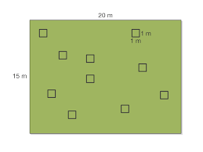For example:

If you wanted to estimate the number of flowers in a field you would use random sampling to calculate a mean and then use that to estimate the total number in the field, based on its area. The quadrats in the diagram on the right are **randomly** placed and then used to calculate the number of organisms or species present in each quadrat.

Systematic sampling

* Placing quadrats at **regular intervals** along a transect line
* Used for investigating the **effect** of an abiotic factor

For example:

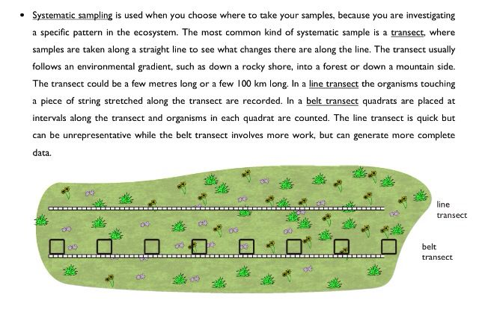If you wanted to investigate the effect of water on the growth of a certain species you would use systematic sampling to make a transect line through different habitats (e.g. woodland, river, marsh) and use quadrats at **regular intervals** to determine if there are significant differences. The number of organisms or species in the quadrat at each interval can be counted to determine if the chosen factor has an effect.

*Note: a quadrat is a frame (see image) that is used to count the number of organisms in an area where it is placed.*

1. Determine if the following statements are true or false:

Activities

and Practice

1. Biodiversity is the variety of different species in an ecosystem
2. Low biodiversity means that species are not dependent on only one food source
3. Sampling techniques can be used to measure the abundance of different species
4. Biodiversity only refers to species of plants
5. A transect is used to randomly sample the species diversity within a habitat

Practical

Part 1 – Investigating the population size of a plant species using random sampling.

Aim:

Method:

1. Mark out a known area in a field (e.g. 20 m by 20 m)
2. Select 10 different sets of random coordinates (e.g. using random number generator)
3. Place a quadrat at the first set of coordinates
4. Count the number of organisms (e.g. the number of daisies) within the quadrat
5. Repeat by placing the quadrat at the other random coordinates
6. Use your measurements to calculate a mean number of organisms per quadrat
7. Estimate the size of the population using:

*Estimated population size = (total area) x mean number of organisms per quadrat*

*area sampled*

Results:

Part 2 – Investigating the effect of a factor on plant distribution using systematic sampling.

Aim:

Hypothesis:

Method:

1. Lay out a tape measure on over a clear 10 m of the field
2. Place the quadrat on the ground at the 0 metres mark
3. Count the number of organisms in the quadrat
4. Move 2 m further along the measuring tape and repeat the process (using quadrats at regular intervals of 2 m) until you reach 10 m

*Note: If light intensity is the factor being investigated, a light meter can be used to measure the light intensity at each interval.*

Results:

1. Biodiversity is…

Exit Ticket

A. How many plants and animals live in a particular habitat

B. The number of plants and animals within an ecosystem

C. The variety of different species in an ecosystem

2. Which type of sampling would be used to investigate the effect of shade on the growth of flowers in a field ?

A. Systematic sampling using a transect and quadrats at regular intervals

B. Random sampling using quadrats at random coordinates

C. Quadrats randomly placed in a sunny area and a shaded area

3. Why is high biodiversity useful for an ecosystem?

A. So that plants and animals have lots of food

B. It allows animals to have lots of choice when choosing their food

C. It means that each species it not dependent on just one other species

For question 1, read the guidance below and carry out the ‘fix-it’ task which has been set for you.

If you answered A

High biodiversity is good for an ecosystem as it means each species is not dependent on one other species. Biodiversity is a measure of the variety of species in an ecosystem, which includes the different species and the genetic differences within a species. How many plants and animals live in a particular habitat is a measure of biodiversity but is not the correct scientific definition.

*Explain the difference between an ecosystem with high biodiversity and an ecosystem with low biodiversity.*

If you answered B

High biodiversity is good for an ecosystem as it means each species is not dependent on one other species. Biodiversity is a measure of the variety of species in an ecosystem, which includes the different species and the genetic differences within a species. The number of plants and animals within an ecosystem can be used as a measure of biodiversity but is not the correct scientific definition.

*Explain what is meant by the genetic differences within a species.*

If you answered C

High biodiversity is good for an ecosystem as it means each species is not dependent on one other species. Biodiversity is a measure of the variety of species in an ecosystem, which includes the different species and the genetic differences within a species.

*Explain why deforestation is reducing biodiversity. Suggest a human activity that could increase biodiversity.*

Do Now:

New Learning

How Humans Affect Biodiversity

1. State the definition of biodiversity.

________________________________________________________________________

1. State the definition of an ecosystem.

________________________________________________________________________

1. Explain why high biodiversity is important for an ecosystem.

________________________________________________________________________

1. State the type of sampling that would be useful to estimate the total population of dandelions in a field.

________________________________________________________________________

1. Explain why it is important to take repeat measurements.

________________________________________________________________________

**Foundation:** Describe what a quadrat is used for.

________________________________________________________________________

________________________________________________________________________

**Stretch:** Describe the different types of pollution.

________________________________________________________________________

________________________________________________________________________

Many human activities are having a **negative** **impact** on **biodiversity** on Earth. For future survival of humans, and a huge number of other species, action must be taken now to maintain biodiversity.

The **human population** has increased exponentially from around 2 billion in 1920 to nearly **8 billion** in 2020. This huge growth in population means that more **resources** are needed, and much more **waste** is produced. Quality of life now is also better than it has ever been, which also causes more waste to be produced.

Imagine if the population of your school doubled. There would then need to be twice as many classrooms, twice as many teachers and twice as many toilets. There would also be twice as much paper to be recycled and twice as much litter dropped!

Another way humans are impacting biodiversity is by introducing **non-indigenous** species to ecosystems. Introducing non-indigenous species can reduce biodiversity if the species out-competes or kills **indigenous** species.

This could mean the non-indigenous species:

* Is a **predator** to indigenous species
* **Outcompetes** indigenous species for food
* Destroys the habitats of indigenous species

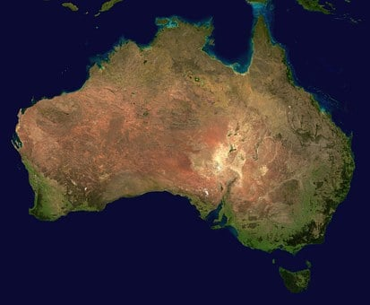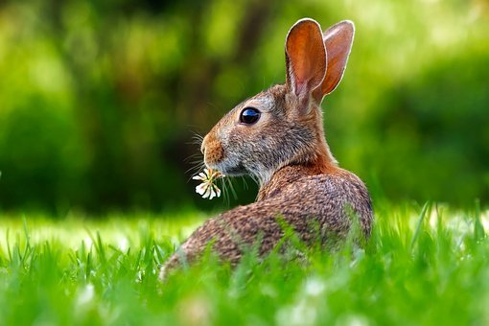An example of a non-indigenous species, which means that that species is not naturally found in that particular habitat, that destroyed a huge area of habitats in Australia was the introduction of European rabbits. In 1859 European rabbits were introduced into the Australian wild by settlers so they could hunt them. It is thought that only 13 rabbits were introduced, but in only 50 years, the invasive (non indigenous) rabbits had spread across the entire country.

*What effect did the rabbits has on the indigenous plants and animals?*

They would have eaten many of the crops, reducing food for humans and eaten many of the plants, reducing food for the indigenous herbivores. They also negatively affected agriculture and plants by overgrazing. This led to habitats of other species being destroyed and subsequently reduced biodiversity. Rabbits are very adaptive and only need soil for burrowing and grass for grazing meaning they can live well in many habitats. They reproduce very rapidly at a young age and can produce up to 20 kittens (baby rabbits) in a year. As rabbits were non-indigenous, they have no natural predators in Australia and therefore took over very easily. It is now illegal to own a pet rabbit in the state of Queensland, Eastern Australia!

Humans reduce the amount of **land** **available** through:

building

quarrying

farming

waste disposal

deforestation

* **Deforestation** is the clearing of large areas of forest so that the land can be used for cattle farming, rice farming and for growing crops used as biofuel

**Peat** is formed when dead plant material cannot decay because of **acidic** and **anaerobic** conditions.

Peat is formed in waterlogged conditions which prevents plants and mosses, decaying when they die because of the lack of oxygen and the acidic conditions. Instead, they build up very slowly to form peat. This started to form 10,000 years ago and sometimes the peat can be more than 10 metres deep.

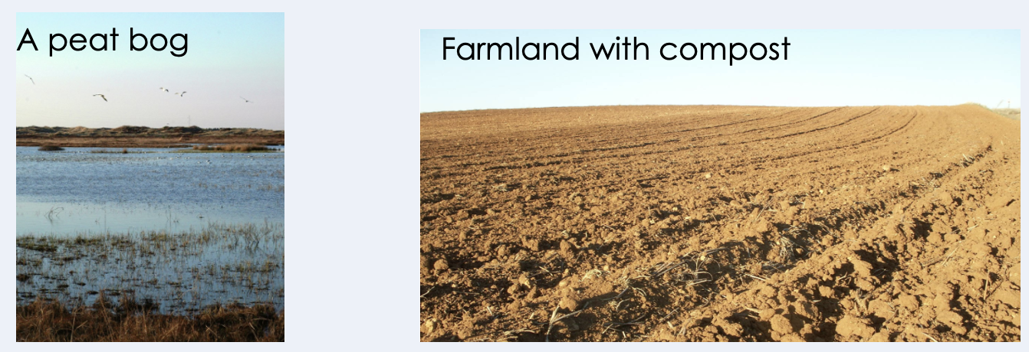Peat bogs are an important habitat for a huge variety of plants, animals and microorganisms which can survive in the acidic conditions – humans need peat for making compost, which is needed for gardening and farming (to help increase food production).

Digging up peat bogs causes a **decrease in biodiversity** because the habitat of many organisms is being destroyed. Peat can also be dried and then burnt as a fuel. As it takes thousands of years to form, the destruction of peat bogs is happening much faster than they can be regenerated.

Peat stores a lot of carbon (as it comes from organic plant material), so when it is burnt or is decaying, it releases carbon dioxide into the atmosphere. Increasing the levels of carbon dioxide in the atmosphere is not a good thing. Elevated atmospheric CO2 levels contributes to global warming (which we will look at in more detail later in the unit).

Ecologists measure things in ecosystems to assess what is happening

Environmental data can often be **uncertain or incomplete.**

Scientists can decrease the uncertainty in their data by taking many readings and repeating their experiments to make their data more **accurate**.

Deforestation is thought to have increased between 1990 and 2000. The picture below shows part of the Amazon in 2000.

*What information do scientists need to support this theory?*

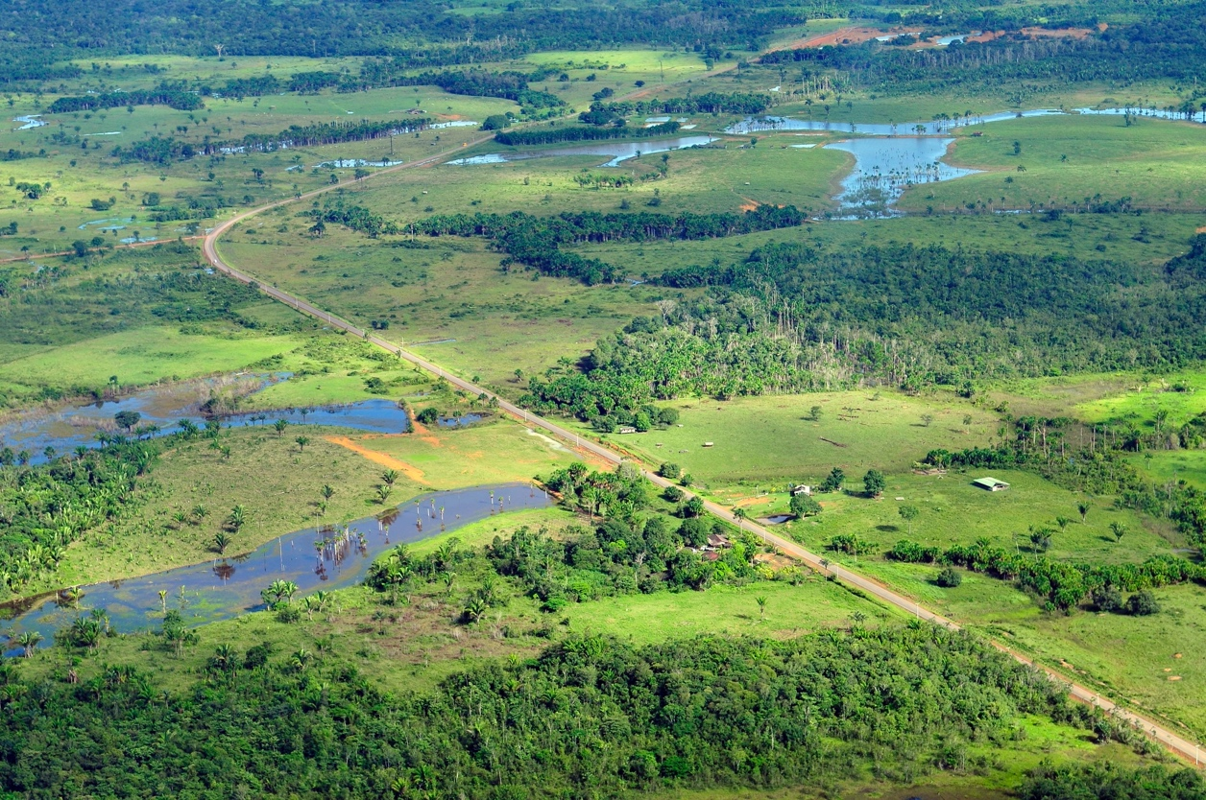They need evidence (in the form of photos, tables or other data) to show how the land use has changed. This photo alone does not support a theory because there is no comparison.

Deforestation can decrease biodiversity because habitats are destroyed so we can assume biodiversity in this area has decreased.

*In what ways is this ‘data’ incomplete?*

It cannot tell us:

* how many trees were removed (it can tell us area from satellite)
* what or how many species habitats were destroyed
* what the land is now used for

The image is from 2000, which is more than 20 years old. Given the change that happened between 1990 and 2000 there could be massive changes that have happened since 2000 therefore the data is not up to date and therefore unreliable. It could be good to suggest that more recent images would be similar to repeating an experiment- the more up to date images we have the more accurate the conclusions would be. However, even with more images the data would still not be totally complete as there are points(from above) that would still not be answered.

1. Answer the following questions.

Activities

and Practice

* + - 1. What are the effects of the human population increasing?

_____________________________________________________________________

_____________________________________________________________________

* + - 1. What is the disadvantage of using peat bogs for compost?

_____________________________________________________________________

_____________________________________________________________________

* + - 1. Why is it important for humans that biodiversity is maintained?

_____________________________________________________________________

_____________________________________________________________________

* + - 1. Name three ways that humans are destroying animal habitats.

_____________________________________________________________________

_____________________________________________________________________

|  |  |
| --- | --- |
| Year | Estimated Amazon Deforestation Rate (km2/year) |
| 2010 | 6400 |
| 2016 | 7800 |
| 2017 | 6700 |

1. Use the data from that table above to answer the following questions.
2. Describe the deforestation rates between 2010 and 2017.

_____________________________________________________________________

_____________________________________________________________________

1. How could this affect the biodiversity of the Brazilian rainforest?

_____________________________________________________________________

_____________________________________________________________________

1. Explain whether this data allows you to make an accurate conclusion about the change in deforestation rate.

_____________________________________________________________________

_____________________________________________________________________

1. How could the accuracy of this data be increased?

_____________________________________________________________________

_____________________________________________________________________

1. 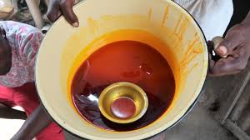There is growing pressure on national Governments to ban the use of Palm Oil in cosmetics and toiletries, as large areas of palm trees in Africa and South East Asia have been destroyed to manufacture the oil.

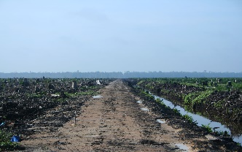The palm oil industry involves thousands of jobs in different countries but its manufacturing process often destroys the habitat of many species.

1. **Evaluate** the use of palm oil in the cosmetic industry, citing arguments both for and against its use.
2. Determine whose responsibility it is to reduce the use of palm oil.

_____________________________________________________________________

_____________________________________________________________________

_____________________________________________________________________

_____________________________________________________________________

_____________________________________________________________________

_____________________________________________________________________

_____________________________________________________________________

_____________________________________________________________________

_____________________________________________________________________

_____________________________________________________________________

_____________________________________________________________________

_____________________________________________________________________

1. Which statement is correct?

Exit Ticket

A. It is fine to destroy peat bogs as long as peat is not burnt

B. Peat bogs are a very large carbon store

C. No species can live in a peat bog as it is acidic

2. Which best explains an effect of a growing population?

A. Humans need more food than animals so more crops have to be grown

B. More humans are growing bigger so need more food

C. Humans are destroying habitats to be able to grow more crops

3. Which of these actions would not decrease biodiversity?

A. Maintaining natural land

B. Introducing a new species into an ecosystem

C. Clearing forests to grow one single crop

For question 3, read the guidance below and carry out the ‘fix-it’ task which has been set for you.

If you answered A

Many human activities are reducing biodiversity but there are some actions that do not reduce biodiversity. Maintaining natural land would prevent habitat destruction in those areas, allowing the species that live there to continue, meaning that maintaining natural land is a way of increasing biodiversity.

*Explain why introducing a new species may decrease biodiversity.*

If you answered B

Many human activities are reducing biodiversity but there are some actions that do not reduce biodiversity. Maintaining natural land would prevent habitat destruction in those areas, allowing the species that live there to continue, meaning that maintaining natural land is a way of increasing biodiversity. Introducing a new species into an ecosystem may decrease biodiversity if the new species outcompetes existing species.

*The native red squirrel population in the UK has decreased rapidly since the introduction of the North American grey squirrel. Suggest why this has happened.*

If you answered C

Many human activities are reducing biodiversity but there are some actions that do not reduce biodiversity. Maintaining natural land would prevent habitat destruction in those areas, allowing the species that live there to continue, meaning that maintaining natural land is a way of increasing biodiversity. Clearing forests to grow one single crop would mean there is only one species of crop present rather than the huge variety of species in a forest.

*Compare the biodiversity of a crop field and a forest.*

Do Now:

New Learning

How Humans Can Preserve Biodiversity

1. State the definition of biodiversity.

________________________________________________________________________

1. State the definition of an ecosystem.

________________________________________________________________________

1. Explain why high biodiversity is important for an ecosystem.

________________________________________________________________________

1. Identify three resources that plants compete for.

________________________________________________________________________

1. Round 34928 to three significant figures.

________________________________________________________________________

**Foundation:** Explain the difference between a habitat and an ecosystem?

________________________________________________________________________

________________________________________________________________________

**Stretch:** Explain how the introduction of a non-indigenous species can affect biodiversity in an area.

________________________________________________________________________

________________________________________________________________________

What can we do to improve biodiversity?

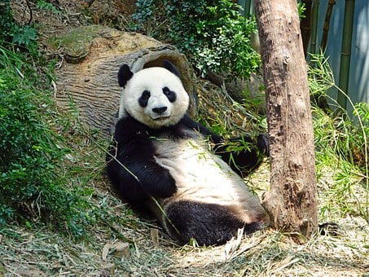Scientists and many global citizens are using a variety of different methods to try to reduce the effect of human impact on diversity. These methods include:

* Protecting rare **habitats**, including nature reserves
* Reducing **deforestation**
* **Recycling** resources and materials to send less to landfill
* Growing **hedgerows** on farms – where there may have only been one crop growing, hedgerows can divide land and allow others to grow, or act as windbreaks to make conditions easier for some plants
* **Breeding** programmes for endangered species

*Note: not all breeding programmes have a positive effect on biodiversity. Selective breeding has a negative effect on biodiversity because it reduces the genetic variation within a species. Breeding endangered animals often helps increase biodiversity because it means that species is maintained.*

Introducing **new species** to an ecosystem can also have different effects. Although the biodiversity may initially increase because there is another species, if the new species outcompetes existing species and leads to them dying out, it has a negative effect on biodiversity.



Activities

and Practice

1. Determine if the following statements are true or false.
2. An example of a rare habitat that is protected is a coral reef
3. Reintroducing hedgerows on farms decreases biodiversity
4. All breeding programmes always increase biodiversity
5. Deforestation is planting new trees to increase biodiversity
6. Describe the different actions humans can take to help maintain biodiversity.

________________________________________________________________________

________________________________________________________________________

________________________________________________________________________

________________________________________________________________________

________________________________________________________________________

________________________________________________________________________

1. State the definition of:
   1. Biodiversity

_____________________________________________________________________

_____________________________________________________________________

* 1. Habitat

_____________________________________________________________________

_____________________________________________________________________

* 1. Ecosystem

_____________________________________________________________________

_____________________________________________________________________

1. Complete the table by organise the following actions into the correct column to decide what effect they could have on biodiversity:

* Building and maintaining nature reserves
* Rainforest habitat destruction
* Bringing new species into a habitat
* Breeding programmes
* Hunting and fishing quotas
* Vaccinating against specific diseases

|  |  |  |
| --- | --- | --- |
| Increase Biodiversity | Decrease Biodiversity | Could increase or decrease Biodiversity |
|  |  |  |

1. For any statements you decided could increase or decrease biodiversity explain your reasoning.

________________________________________________________________________

________________________________________________________________________

________________________________________________________________________

________________________________________________________________________

________________________________________________________________________

1. Determine if the following statements are true or false. If the statements are false, correct them to make them true statements.
   1. Humans are at the top of the food chain so we are much more important than other species

_____________________________________________________________________

_____________________________________________________________________

* 1. It is important to maintain biodiversity for future generations

_____________________________________________________________________

_____________________________________________________________________

* 1. Only people that are involved in the manufacture and distribution of resources should be responsible for reducing their use.

_____________________________________________________________________

_____________________________________________________________________

* 1. An individual person cannot make a difference

_____________________________________________________________________

_____________________________________________________________________

* 1. A decrease in genetic variation will cause a decrease in biodiversity

_____________________________________________________________________

_____________________________________________________________________

* 1. Pollution always kills plants and animals

_____________________________________________________________________

_____________________________________________________________________

* 1. Habitat destruction and decreasing biodiversity is always a result of human activities

_____________________________________________________________________

_____________________________________________________________________

1. Which of the following is not a way to maintain biodiversity?

Exit Ticket

A. Protecting rare habitats

B. Selective breeding programmes

C. Reducing deforestation

2. Why would a farmer grow hedgerows on their farm?

A. To use hedgerows as crops to sell

B. To increase crop yield by making more space

C. To increase biodiversity

3. Which of these actions would increase biodiversity?

A. Maintaining nature reserves

B. Introducing a new species into an ecosystem

C. Using a selective breeding programme to produce more individuals with a desired characteristic

For question 3, read the guidance below and carry out the ‘fix-it’ task which has been set for you.

If you answered A

Many human activities are reducing biodiversity but there are some actions that can increase biodiversity, or reduce the impact of humans. Maintaining nature reserves would prevent habitat destruction in those areas, allowing the species that live there to continue, meaning that maintaining nature reserves is a way of increasing biodiversity.

*Explain why breeding programmes do not always have a positive impact on biodiversity.*

If you answered B

Many human activities are reducing biodiversity but there are some actions that can increase biodiversity, or reduce the impact of humans. Introducing a new species into an ecosystem may initially increase biodiversity, but it may also decrease biodiversity if the new species outcompetes existing species.

*Give an example of the introduction of a new species into an ecosystem and describe the effect.*

If you answered C

Many human activities are reducing biodiversity but there are some actions that can increase biodiversity, or reduce the impact of humans. Using a selective breeding programme to produce more individuals with a desired characteristic would mean that more individuals had similar genes, reducing the genetic variation of the species and therefore reducing biodiversity.

*Explain the meaning of biodiversity and how genetic variation fits into it.*

Do Now:**

New Learning

The Effect of Pollution on Biodiversity

1. Define the term deforestation.

________________________________________________________________________

1. State three human activities that reduces biodiversity.

________________________________________________________________________

1. State three actions that can increase biodiversity.

________________________________________________________________________

1. Name the piece of equipment used in both random and systematic sampling.

________________________________________________________________________

1. Identify a biotic factor that can affect a community.

________________________________________________________________________

**Foundation:** List the sources of waste water from a home.

________________________________________________________________________

**Stretch:** Suggest how home could reduce the amount of waste water they produce.

________________________________________________________________________

________________________________________________________________________

The human population is approximately **7.7 billion**. The increase in population over the last century means there is a greater **demand** for **resources** and **more waste** is produced.

Pollution is caused when **waste** is not properly handled.

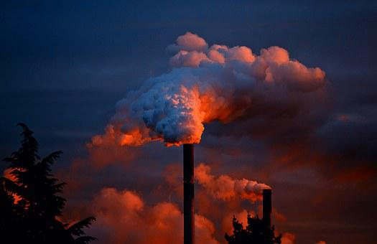**Air pollution** comes from lots of industrial processes where smoke is released, containing **carbon dioxide** and **sulfur dioxide** among other substances. Cars, buses, trains and planes also all produce carbon dioxide through the burning of petrol and other fuels.

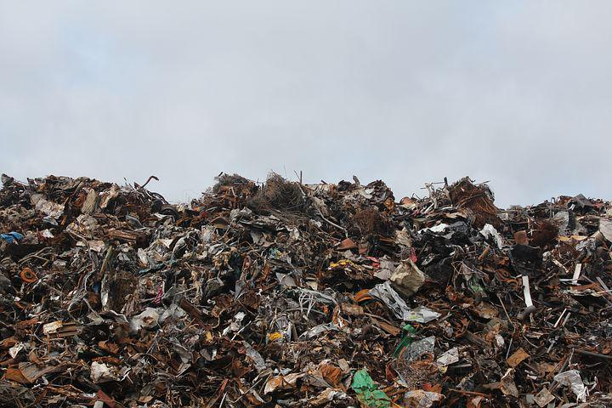**Water pollution** is mainly caused by poor **sewage** treatment and **eutrophication** of fertilisers. Water pollution can spread toxic substances through food chains as they can be absorbed by producers and then passed onto consumers.

**Land pollution** involves the filling up of landfill sites, which often means that habitats of plants and animals are destroyed. It can also lead to soil contamination, where toxic substances are absorbed into the ground. The largest landfill site in the world is in Puente Hills in California, at over 2.8 km2 and over 150 metres high.

Pollution can be very harmful for plants and animals, but does not necessarily affect all species in the same way. Some species are more resistant to pollution and have adapted to be able to live in polluted environments.

*Note: often people think that pollution directly kills plants and animals. Although this can happen sometimes (such as toxic sewage killing aquatic animals) more often pollution damages habitats or food sources.*

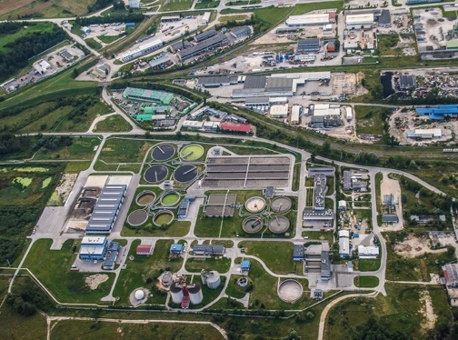The processing and treatment of waste water includes the following steps:

* **Screening** and **grit** removal to take out large pieces
* **Sedimentation** to separate sludge and effluent (the liquid that remains on top)
* **Sludge** is digested by specific bacteria
* **Effluent** is treated with specific bacteria and chemicals

*What happens if waste water from farms gets into rivers or streams?*

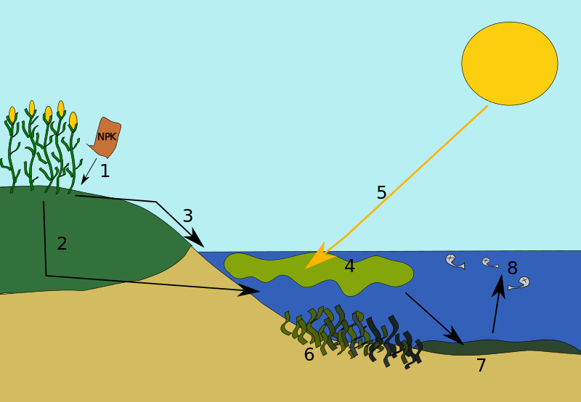Some farmers use too many fertilisers to promote growth of their crops, which can run off fields during periods of heavy rain, which then gets streams and rivers leading to **eutrophication**.

Eutrophication happens in these stages:

1- Fertiliser applied to crops

2/3- Fertilisers from farmers’ fields can leach into lakes, rivers streams etc.

4- The fertilisers which are rich in nutrients (nitrates and phosphates) can cause a rapid, explosive growth in plants and algae in the water

5- These plants and algae block sunlight from any plants beneath them. This means plants underneath cannot photosynthesise to survive and do not produce oxygen

6/7- The plants and organisms in the water die, decomposers (bacteria) break them down. Increased numbers of decomposers use up any remaining oxygen in the water

8- Finally, water that is completely depleted of oxygen becomes a dead zone and can no longer support life

Scientists can use the presence or absence of certain species to deduce the levels of pollution in an area.

**Lichens** can be used as air pollution indicators. They are especially sensitive to the concentration of sulfur dioxide in the atmosphere. Lichens are organisms that grow in exposed places such as rocks or tree bark. They need to be very good at absorbing water and nutrients to grow there. Air pollutants dissolved in rainwater, especially sulfur dioxide, can damage lichens and prevent them from growing. This makes lichens natural indicators of air pollution. If bushy lichen are present in an area it is an indicator that the air is very clean. Leafy lichen can withstand small amounts of air pollution whereas crusty lichen can survive in areas with more polluted air. If no lichen are present it is a sign that the air is heavily polluted with sulfur dioxide.

**Indicator species** are organisms that can tell us about the levels of pollution in an area by their presence or absence.

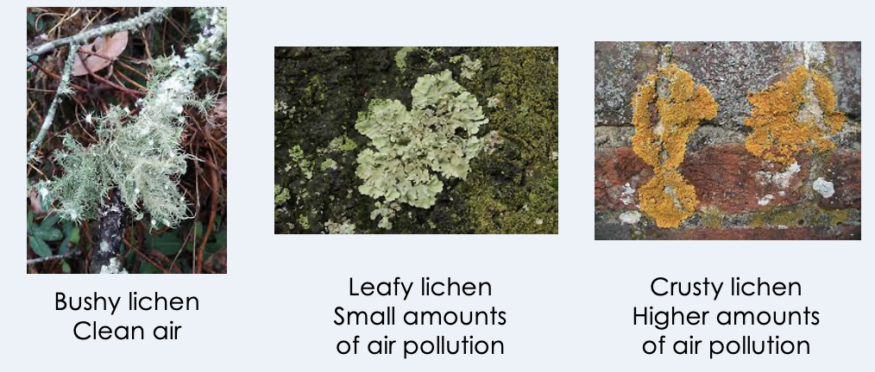

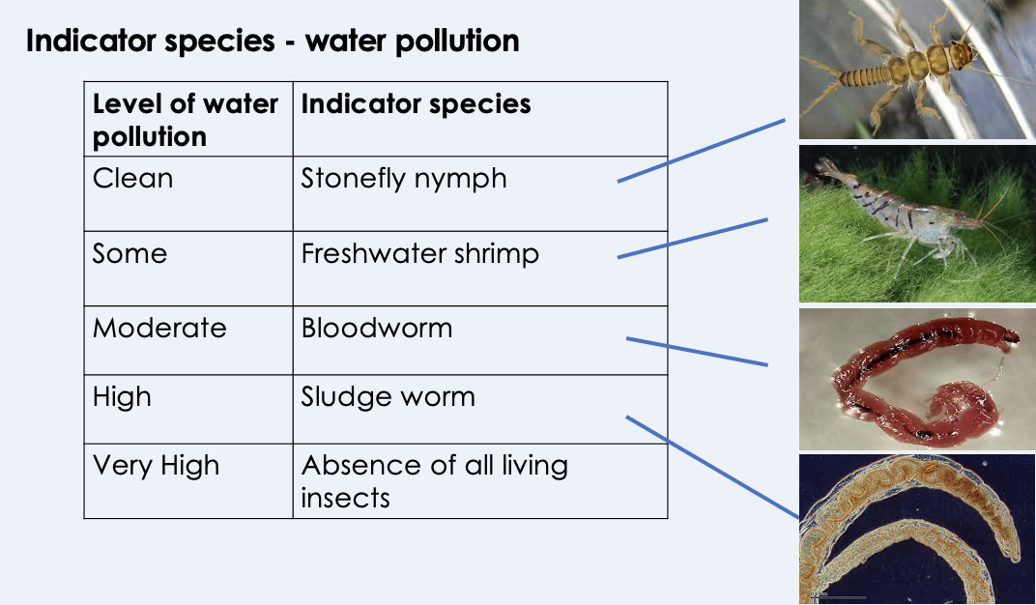Many **aquatic** invertebrate animals cannot survive in water that has been polluted or has resulted in a lowering of the oxygen concentration, so their presence or absence indicates the extent to which a body of water is polluted.



Activities

and Practice

1. If these are the answers, what were the questions?
2. Greater demand for resources and more waste produced
3. Sewage, fertilisers and toxic chemicals
4. Production of any substances that are harmful to plants or animals

d. Fertilisers run into bodies of water causing explosive plant/algae growth that ultimately result in ‘dead zones’ of water.

|  |  |  |
| --- | --- | --- |
| Distance from city centre (km) | Concentration of SO2 (g/m3) | Number of different lichen species found on trees |
| 0 | 300 | 1 |
| 5 | 212 | 5 |
| 10 | 145 | 10 |
| 15 | 77 | 14 |
| 20 | 75 | 14 |

1. Use data from the table above to answer the following questions.
2. Describe how the distance from the city centre affects the number of lichen species found.

_____________________________________________________________________

_____________________________________________________________________

_____________________________________________________________________

_____________________________________________________________________

1. Use the concentration of sulfur dioxide to explain the findings.

_____________________________________________________________________

_____________________________________________________________________

1. A farmer uses fertiliser on his field. Later that day is rains heavily. The waste water overflows into a stream by mistake.

The waste water will have an effect on the plants and invertebrates living in the stream.

**Explain** why.

_____________________________________________________________________

_____________________________________________________________________

_____________________________________________________________________

_____________________________________________________________________

_____________________________________________________________________

_____________________________________________________________________

_____________________________________________________________________

_____________________________________________________________________

_____________________________________________________________________

_____________________________________________________________________

1. Which correctly explains why humans are now producing more waste?

Exit Ticket

A. Humans now have a worse quality of life so fewer resources are used

B. The human population has increased hugely over the last century

C. Many resources can now be recycled so we can throw away non-recyclable items

2. What is a consequence of not treating waste water?

A. Contamination of water sources, leading to severe illnesses

B. Factories illegally leaking toxic chemicals into streams and rivers

C. Run off of fertilisers from farms after heavy rain

3. Why is pollution bad for many plants and animals?

A. Pollution kills all plants and animals

B. Pollution is harmful for many habitats and can spread toxic substances through food chains

C. Pollution increases biodiversity

For question 3, read the guidance below and carry out the ‘fix-it’ task which has been set for you.

If you answered A

Pollution is caused by waste not being treated properly and includes air, water and land pollution. Although pollution can be harmful to many plants and animals it does not necessarily kill all plants and animals directly. It is more likely that toxic substances make their way into food chains, which can harm plants and animals.

*Explain how indicator species can be used to show how polluted a habitat is.*

If you answered B

Pollution is caused by waste not being treated properly and includes air, water and land pollution. Although pollution can be harmful to many plants and animals it does not necessarily kill all plants and animals directly. It is more likely that toxic substances make their way into food chains, which can harm plants and animals.

*Explain how lichen can be used to show the air quality of an area.*

If you answered C

Pollution is caused by waste not being treated properly and includes air, water and land pollution. Although pollution can be harmful to many plants and animals it does not necessarily kill all plants and animals directly. Pollution decreases biodiversity because it can harm many different plants or animals.

*Explain what it means to have high biodiversity in an area.*

Do Now:

New Learning

Global Warming

1. Explain the term pollution.

________________________________________________________________________

1. Explain what is meant by the term ‘waste’.

________________________________________________________________________

1. Give one source of water pollution.

________________________________________________________________________

1. Identify two resources that animals compete for.

________________________________________________________________________

1. Convert the number 3.4 x 10-3 from standard form.

________________________________________________________________________

**Foundation:** What has happened to the number of cars and aeroplanes used over the last century?

________________________________________________________________________

**Stretch:** Are aeroplanes or cars responsible for more pollution? Explain your answer.

________________________________________________________________________

________________________________________________________________________

**Climate change** is the overall change in weather (global or regional) over a long period of time.

**Global warming** is the rise in global temperatures due to greenhouse gases.

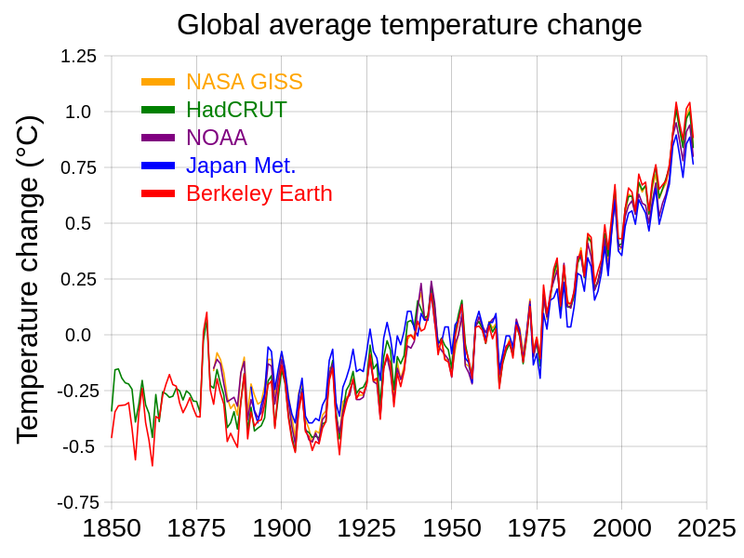Levels of **carbon dioxide** and **methane** in the Earth’s atmosphere are increasing. This is mainly due to the increased burning of **fossil fuels**, such as coil, oil and natural gas. This happens in many industrial processes in factories, as well as cars, buses, trains and aeroplanes.

**Deforestation** also means that there are fewer trees to absorb some of the carbon dioxide from the atmosphere for photosynthesis.

Carbon dioxide and methane are **greenhouse gases**, which are contributing to global warming.

Global warming is the **overall rise in the temperature of the Earth’s atmosphere**. This happens when greenhouse gases become trapped in the atmosphere and prevent radiation from the sun being able to be reflected fully from the Earth. It can be useful to imagine the Earth as having an extra layer or coat on, which is making it heat up because the heat cannot escape (but make sure you remember that the heat comes from the Sun not the Earth).

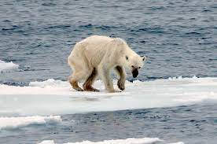There are severe **biological consequences** of global warming:

* Polar **ice** **caps** are **melting**
* **Sea levels** are **rising**
* Many areas are experiencing severe **flooding**
* Many areas are experiencing **extreme weather** patterns, such as droughts or storms

Other biological consequences include:

* 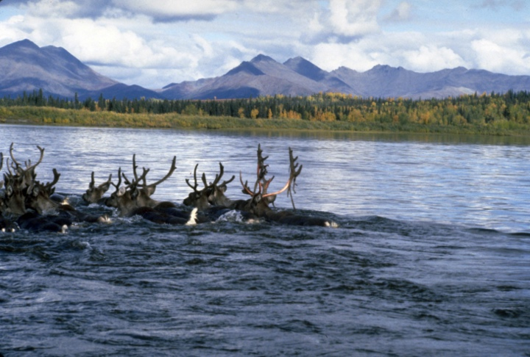**Loss** of **habitats** (often because of one of the other consequences)
* Changing **breeding patterns**
* Changing **migratory patterns**

These biological consequences cause changes to the **biodiversity** of an area.



Activities

and Practice

1. Determine if the following statements are true or false:
2. Global warming and climate change are the same
3. Global warming is caused by increased levels of greenhouse gases
4. Water vapour and oxygen are greenhouse gases
5. Deforestation prevents global warming because it means there are fewer trees to emit carbon dioxide

e. Consequences of global warming include flooding and extreme weather events

1. The projected global drop in carbon dioxide emissions as a result of the coronavirus pandemic is 5.5% from 2019, which would be the largest ever fall in emissions and far greater than any drops seen during economic recessions or war time.

However even this drop is not enough. According to a number of different studies the global emissions would have to drop by 7.6% every year this decade in order to achieve the target of limiting global warming to 1.5 °C above pre-industrial temperatures.

1. Describe the consequences of global warming if this target is not met.
2. Suggest actions that governments and individuals could take to reduce their carbon dioxide emissions.
3. Suggest why there was such a significant drop in emissions during the pandemic.

________________________________________________________________________

________________________________________________________________________

________________________________________________________________________

________________________________________________________________________

________________________________________________________________________

________________________________________________________________________

________________________________________________________________________

________________________________________________________________________

________________________________________________________________________

________________________________________________________________________

________________________________________________________________________

________________________________________________________________________

________________________________________________________________________

________________________________________________________________________

________________________________________________________________________

________________________________________________________________________

________________________________________________________________________

________________________________________________________________________

________________________________________________________________________

________________________________________________________________________

________________________________________________________________________

________________________________________________________________________

________________________________________________________________________

________________________________________________________________________

________________________________________________________________________

________________________________________________________________________

________________________________________________________________________

________________________________________________________________________

________________________________________________________________________

________________________________________________________________________

________________________________________________________________________

1. Which is the best definition of global warming?

Exit Ticket

A. Changing weather patterns

B. The Earth getting hotter

C. The increase in the overall temperature of the Earth’s atmosphere

2. Which is not a consequence of global warming?

A. Rising sea levels and flooding

B. Fossil fuels being burned

C. Extreme weather patterns

3. Which would be an action to reduce greenhouse gas emissions?

A. Cutting down trees

B. Using renewable energy sources

C. Burning waste instead of sending it to landfill

For question 2, read the guidance below and carry out the ‘fix-it’ task which has been set for you.

If you answered A

Global warming is the increase in the temperature of the Earth’s atmosphere and has serious biological consequences. There is an important difference between causes and effects. Global warming is caused by the burning of fossil fuels and deforestation because of the excess greenhouse gases produced. The effects or consequences include rising sea levels and flooding.

*Explain the causes and effects of global warming.*

If you answered B

Global warming is the increase in the temperature of the Earth’s atmosphere and has serious biological consequences. There is an important difference between causes and effects. Global warming is caused by the burning of fossil fuels and deforestation because of the excess greenhouse gases produced. This means that burning of fossil fuels is a cause of global warming rather than a consequence. The effects or consequences include rising sea levels and flooding.

*Describe some human actions that could be used to reduce global warming.*

If you answered C

Global warming is the increase in the temperature of the Earth’s atmosphere and has serious biological consequences. There is an important difference between causes and effects. Global warming is caused by the burning of fossil fuels and deforestation because of the excess greenhouse gases produced. The effects or consequences include extreme weather patterns.

*Explain the difference between a cause and a consequence.*

Do Now:

New Learning

Pyramids of Biomass

1. State the definition of a producer.

________________________________________________________________________

1. Draw a food chain to show the feeding relationships between a lion, a zebra and grass.

________________________________________________________________________

1. Identify the apex predator in your food chain from Q2.

________________________________________________________________________

1. What do the arrows in a good chain represent?

________________________________________________________________________

1. Convert the number 12000 into standard form.

________________________________________________________________________

**Foundation:** Identify the primary and secondary consumers in Q2.

________________________________________________________________________

**Stretch:** Explain what would happen to the population of lions in the food chain if there was a new disease that affected grass.

________________________________________________________________________

________________________________________________________________________

**A pyramid of biomass**  is a graphical representation of biomass at each trophic level (stage of a food chain).

**Biomass** is a measure of the total quantity of organic (living or recently dead) material.

Pyramids of biomasstake into account the number of each organism as well as how big each organism is, which a pyramid of numbers does not show you.

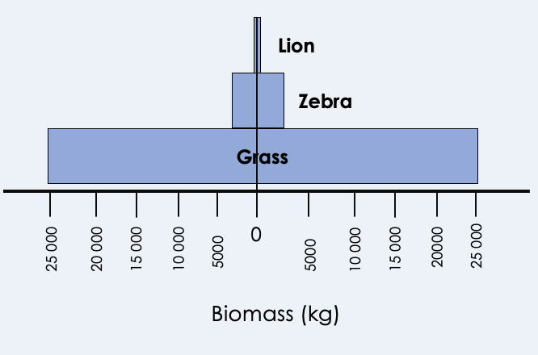Biomass is lost between trophic levels as energy is lost between levels.

*Grass = 10 000 000 blades x 5 g each*

*Biomass of grass = 50 000 kg*

*Zebra = 25 x 200 kg each*

*Biomass of zebra = 5 000 kg*

*Lion = 2 x 300 kg*

*Biomass of lion = 600 kg*

**Producers** are always at the base of a pyramid of biomass. Producers are mostly plants and algae, which make their own food (in the form of glucose) using energy from the Sun for photosynthesis. They transfer approximately 1 % of the light energy they absorb for photosynthesis onto the next trophic level.

Only around **10 % of biomass** from each level is **passed on** to the next level. This is because a lot of biomass is lost or not absorbed by the next level:

* Not all material is **ingested** (eaten) or absorbed after being eaten
* Some absorbed material is lost as **waste** (urine, faeces, sweat etc)
* Some energy is expended in **life processes**, such as **growth**, **movement** and **thermoregulation** (keeping a constant body temperature)

**Percentage efficiency transfer = biomass is higher trophic level x 100  
 biomass in lower trophic level**

The **efficiency of biomass transfers** is a measure of how much biomass has been passed on from one trophic level to another (and how much has therefore been wasted).

Example

Calculate the percentage efficiency transfer between the zebra and the lion.

**Lion**

**Zebra**

Biomass of Lion = 600 kg

Biomass of Zebra = 5000 kg

Percentage = biomass in higher trophic level (lion) x 100  
Efficiency biomass in lower trophic level (zebra)  
Transfer = 600 x 100  
 5000  
 = 12 %

**Grass**

1. State the definition of:

Activities

and Practice

a. A producer

_____________________________________________________________________

1. A consumer

_____________________________________________________________________

1. Use the following pyramid of biomass to answer the questions:

**Orca**

**Penguin**

**Herring**

**Plankton**

1. What is the producer in this food chain?

_____________________________________________________________________

_____________________________________________________________________

1. State the key words you could use to describe:

i. Herring

__________________________________________________________________

ii. Penguin

__________________________________________________________________

iii. Orca

__________________________________________________________________

1. Use the following information to:
2. Calculate the biomass of each trophic level
3. Draw a pyramid of biomass to represent the information. Use 1 box = 100 kg.
4. Calculate the percentage efficiency transfer at each level

30 000 carrots, each with a dry mass of 50 g

80 rabbits, each with a mass of 2 kg

2 foxes, each with a mass of 10 kg.

Calculations of percentage efficiency transfer at each trophic level:

Calculations of biomass of each trophic level:

1. Use the following information to:
2. Calculate the biomass of each trophic level
3. Draw a pyramid of biomass to represent the information.
4. Calculate the percentage efficiency transfer at each level

1 shark, with a mass of 100 kg

15 seals, each with a mass of 80 kg

1 500 flatfish, each with a mass of 10 kg

200 000 kg of plankton

Calculations of percentage efficiency transfer at each trophic level:

Calculations of biomass of each trophic level:

1. Suggest what life processes would cause the efficiency transfer to not be 100 %.

________________________________________________________________________

________________________________________________________________________

________________________________________________________________________

________________________________________________________________________

________________________________________________________________________

1. A cow eats 10 kg of grass over the course of a week. Its own mass increases by 0.8 kg and it excretes 5.5 kg in waste (urine, faeces and gas).
2. Calculate how much biomass was used up in respiration.
3. Calculate the percentage efficiency transfer (clue – think how much biomass is available to the next trophic level).
4. Explain why there are rarely more than 4 or 5 levels of a food chain.

________________________________________________________________________

________________________________________________________________________

________________________________________________________________________

________________________________________________________________________

________________________________________________________________________

________________________________________________________________________

1. Which is the best description of a pyramid of biomass?

Exit Ticket

A. A representation of the number of organisms in each trophic level

B. A diagram to show how big each organism is compared to others

C. A representation of the amount of organic material in each trophic level

2. Which best explains why only approximately 10% of biomass is passed on to the next trophic level?

A. The rest of the biomass is released as waste (urine and faeces)

B. Biomass is lost at each trophic level through waste and life processes

C. Each trophic level needs to keep the rest of the biomass for themselves

3. Which best explains why food chains rarely have more than 5 levels?

A. The apex predator cannot get any bigger

B. Only approximately 10 % of biomass is passed on to the next trophic level

C. Only half the biomass is passed on so it will eventually run out

For question 3, read the guidance below and carry out the ‘fix-it’ task which has been set for you.

If you answered A

Biomass is lost between trophic levels through waste and life processes. This means that eventually so little biomass will be passed on that the food chain cannot continue. The apex predator is often a large animal but the physical size of the organism is not the reason why food chains do not have more levels. By the time you reach the fourth or fifth level of the pyramid, very little biomass is passed on.

*Describe the ways in which biomass is lost at each trophic level.*

If you answered B

Biomass is lost between trophic levels through waste and life processes. This means that eventually so little biomass will be passed on that the food chain cannot continue*.* By the time you reach the fourth or fifth level of the pyramid, very little biomass is passed on.

*Suggest how the biomass efficiency transfer could be improved (made more efficient).*

If you answered C

Biomass is lost between trophic levels through waste and life processes. This means that eventually so little biomass will be passed on that the food chain cannot continue*.* By the time you reach the fourth or fifth level of the pyramid, very little biomass is passed on. The biomass efficiency transfer is approximately 10 % between levels, not 50 %.

*Explain what is meant by life processes and thermoregulation.*

Do Now:

New Learning

Farming and Biotechnology

1. Where is the producer found in a pyramid of biomass?

________________________________________________________________________

1. What is the approximate biomass efficiency transfer between trophic levels?

________________________________________________________________________

1. Why is not all biomass transferred to the next trophic level?

________________________________________________________________________

1. State the definition of an organism.

________________________________________________________________________

1. Calculate the volume of a space with the dimensions 50 m, 40 m and 12 m.

________________________________________________________________________

**Foundation:** What is the term for organisms that feed on producers?

________________________________________________________________________

**Stretch:** Suggest how the efficiency of biomass transfers could be increased.

________________________________________________________________________

________________________________________________________________________

Efficiency of biomass transfers is only approximately **10 %** because of all the biomass that is lost through waste or used in life processes, such as movement or thermoregulation.

Efficiency can be improved by **restricting energy transfer** from animals that are used as food. This involves **intensive farming** methods, which can sometimes be referred to as battery farming.

Intensive farming methods can involve:

* **Limiting** the animals’ **movement** (usually by keeping them in small cages)
* **Controlling** the **temperature** of the surroundings (so energy is not wasted in thermoregulation)
* Feeding animals **high protein** diets to speed up their growth

Issues with intensive farming:

* **Ethical** objections (based on animal welfare)
* Overuse of **antibiotics** (many farmers use a lot of antibiotics, contributing to antibiotic resistance)

Fish stocks in the ocean are declining because of overfishing. Wild fish populations must be maintained at a level where breeding can still continue, otherwise the species may disappear.

Actions to help conserve ocean fish stocks include:

* Control of **net size** – where holes in the nets must be large enough to allow small or juvenile fish to escape, so they can go on to breed

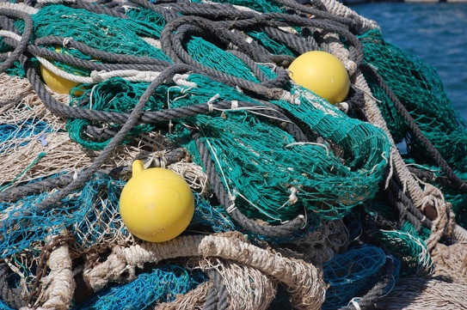

* 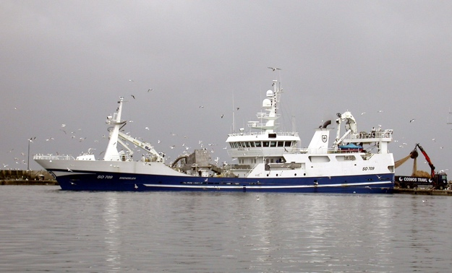**Fishing quotas** – each country is given a certain amount of fish they can catch, which depends on the population of the country and how much they have already fished in the area

Biotechnology

Modern biotechnology allows large quantities of **microorganisms** to be cultured for food. The fungus *Fusarium* is used to produce **mycoprotein**, which is a protein-rich food suitable for vegetarians. In supermarkets you will have seen it labelled as **Quorn**.

*Fusarium* is grown on glucose syrup in aerobic conditions (in the presence of oxygen), before the biomass is harvested and purified.

**Genetically modified** crops can also be produced that have greater nutritional value than non-GM equivalents. **Golden rice** is an example crop, which contains beta-carotene. Beta-carotene is converted into **vitamin A** in the body so it can be very useful in areas where diets do not contain enough vitamin A.

A genetically modified bacterium is also used to produce human insulin, which can be used to treat people with diabetes.



Activities

and Practice

1. Use the following table to answer the questions

|  |  |  |  |
| --- | --- | --- | --- |
| Year | Mass of fish caught by  UK fishermen from  ALL SOURCES  in thousands of tonnes | Mass of fish caught by  UK fishermen from  SUSTAINABLE SOURCES  in thousands of tonnes | Percentage of  fish caught from  sustainable  sources |
| **2002** | 690.0 | 427.8 | 62.0 |
| **2004** | 655.0 | 396.6 | 60.5 |
| **2006** | 619.0 | 386.0 | 62.4 |
| **2008** | 589.0 | 436.1 | 74.0 |
| **2010** | 611.5 | 465.0 |  |

a. Calculate the percentage of fish caught from sustainable sources in 2010.

b. Describe the patterns shown in the table.

___________________________________________________________________________

___________________________________________________________________________

___________________________________________________________________________

___________________________________________________________________________

___________________________________________________________________________

c. Suggest reasons for the patterns shown.

___________________________________________________________________________

___________________________________________________________________________

___________________________________________________________________________

___________________________________________________________________________

d. State two methods of maintaining fish stocks.

___________________________________________________________________________

___________________________________________________________________________

1. Intensive farming methods are often used to make biomass and energy transfers more efficient.

|  |  |
| --- | --- |
| Animals can be transported in small spaces over long distances. |  |
| Keeping temperatures constant reduces the energy that an animal uses to thermoregulate. The energy saved is used for growth. |  |
| Movement of animals is restricted. |  |
| Antibiotics used in farming can be a threat to human health, causing antibiotic resistance. |  |
| Animals cages can be very small and stressful. |  |
| Restricting the movement of animals so that energy used for movement is reduced and more can be used for growth. |  |
| Slaughtering techniques can be inhumane. |  |
| Animals are easily treated with antibiotics to prevent them from getting infections. |  |
| Fewer animal pests to eat crops or cause disease in livestock. |  |
| Animals are packed closely together, increasing the risk of disease spreading. |  |

1. Determine if each of the following statements is an advantage or a disadvantage of intensive farming:
2. Use the table to help you evaluate the advantages and disadvantages of using intensive farming methods.

__________________________________________________________________________________

__________________________________________________________________________________

__________________________________________________________________________________

__________________________________________________________________________________

__________________________________________________________________________________

__________________________________________________________________________________

__________________________________________________________________________________

__________________________________________________________________________________

__________________________________________________________________________________

__________________________________________________________________________________

__________________________________________________________________________________

__________________________________________________________________________________

__________________________________________________________________________________

__________________________________________________________________________________

__________________________________________________________________________________

__________________________________________________________________________________

__________________________________________________________________________________

__________________________________________________________________________________

1. Another way to increase the efficiency of biomass transfer is by limiting the length of food chains. The table below shows the energy available to humans from two different food chains:

|  |  |
| --- | --- |
| Food chain | Energy transferred to humans in kJ per hectare of crop |
| Wheat → humans | 900 000 |
| Wheat → pigs → humans | 90 00 |

1. Explain what the arrows represent in a food chain.

_____________________________________________________________________

___________________________________________________________________________

___________________________________________________________________________

1. Compare the amount of energy the two food chains transfer to humans.

_____________________________________________________________________

___________________________________________________________________________

___________________________________________________________________________

_____________________________________________________________________

___________________________________________________________________________

___________________________________________________________________________

1. Suggest a reason for the difference in the amount of energy the two food chains transfer to humans.

_____________________________________________________________________

___________________________________________________________________________

___________________________________________________________________________

_____________________________________________________________________

___________________________________________________________________________

___________________________________________________________________________

1. Explain how this data could be used as evidence to promote a vegetarian diet. .

_____________________________________________________________________

___________________________________________________________________________

___________________________________________________________________________

_____________________________________________________________________

___________________________________________________________________________

___________________________________________________________________________

1. Which is an advantage of using intensive farming methods?

Exit Ticket

A. Less energy is lost through movement and thermoregulation

B. Populations of animals must be kept very low

C. Animals can be treated with antibiotics

2. Which best explains why fishing quotas are used?

A. So that each country gets the same amount of fish

B. To make sure that not all fish are caught in each trawl

C. To maintain fish populations at a stable breeding level

3. Which is the correct description of mycoprotein?

A. Genetically modified crops with added nutritional value

B. A protein-rich food made from *Fusarium*

C. Bacteria that are used to produce insulin

For question 1, read the guidance below and carry out the ‘fix-it’ task which has been set for you.

If you answered A

Intensive farming methods are used to increase the efficiency of biomass transfers between trophic levels. This involves reducing the amount of energy that is wasted by the food animals on life processes, such as movement and thermoregulation.

*Describe some of the disadvantages of intensive farming methods.*

If you answered B

Intensive farming methods are used to increase the efficiency of biomass transfers between trophic levels. This involves reducing the amount of energy that is wasted by the food animals on life processes, such as movement and thermoregulation. Populations of animals do not need to be kept low for intensive farming methods, usually there are large numbers of animals in small areas.

*Describe how intensive farming methods restrict movement and thermoregulation.*

If you answered C

Intensive farming methods are used to increase the efficiency of biomass transfers between trophic levels. This involves reducing the amount of energy that is wasted by the food animals on life processes, such as movement and thermoregulation. Animals can be treated with antibiotics because they are in close proximity, meaning they are vulnerable to infection. However, this may contribute to antibiotic resistance, so this is a disadvantage of intensive farming.

*Describe how intensive farming methods restrict movement and thermoregulation.*

Do Now:

New Learning

Food Security

1. State two methods of maintaining fish stocks.

________________________________________________________________________

1. State two biological consequences of global warming.

________________________________________________________________________

1. Explain why energy is lost between trophic levels in a food chain.

________________________________________________________________________

1. What is the name of an animal that eats only plants?

________________________________________________________________________

1. Calculate the efficiency of the biomass transfer when there is 500 kg of biomass in trophic level 1 and 40 kg of biomass in trophic level 2.

________________________________________________________________________

**Foundation:** State the definition of a producer.

________________________________________________________________________

**Stretch:** Explain why vegetarianism is referred to as a sustainable diet choice.

________________________________________________________________________

________________________________________________________________________

Food security is having **enough food to feed a population.**

This is something that is taken for granted in many developed countries but can be a serious threat to human life in some developing countries.

A number of biological factors can threaten food security:

* Increasing **birth rate** in some countries, where the population is increasing too fast for resources to keep up
* 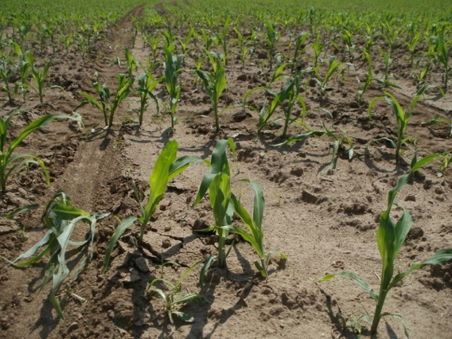**Changing diets** in developed countries, where exotic foods are becoming scarce because of demand in the Western world
* New **pests** and **pathogens**, destroying growth of crops
* **Droughts** and **flooding** – a drought is a sustained period of low rainfall, so crops do not have enough water. Flooding can also be harmful as minerals may be leached out the soil because of excess water.
* Cost of **agricultural inputs** – rising costs of farm equipment, technology and fertilisers
* **Conflicts** in parts of the world – political instability can be a threat to food and water supply

**Sustainability** means supporting long-term ecological and environmental balance by not depleting natural resources.



Activities

and Practice

* + 1. Determine if the following statements are true or false:

1. Food security is having enough food to feed a population
2. Food security is only a threat to developing countries
3. A decreasing birth rate is a threat to food security
4. Food security is a local issue

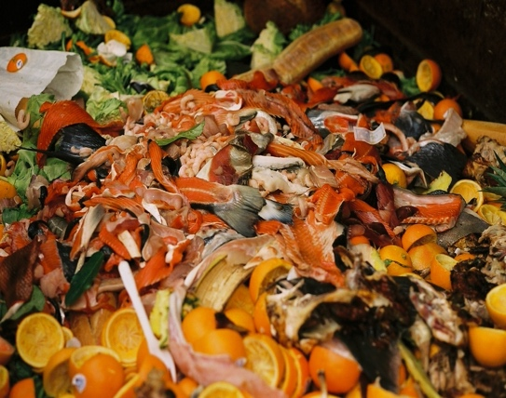Research shows that **6.6 million tonnes** of household food waste was thrown out in the UK in 2018, compared to **8.1 million tonnes** in 2007.

Of the 6.6 million tonnes thrown away**, 70 %** was food that could have been eaten.

* + 1. Describe what has happened to the amount of food waste produced by the UK.

________________________________________________________________________

________________________________________________________________________

________________________________________________________________________

________________________________________________________________________

3. Suggest reasons for this change.

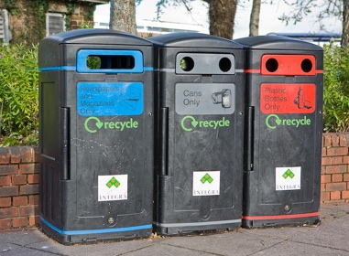_________________________________________________

_________________________________________________

_________________________________________________

_________________________________________________

4. Does this mean that everyone has too much food? ________________________________________________________________________

________________________________________________________________________

________________________________________________________________________

________________________________________________________________________

1. Suggest some initiatives or advice you could give people to reduce the amount of food waste that is produced.

________________________________________________________________________

________________________________________________________________________

________________________________________________________________________

________________________________________________________________________

________________________________________________________________________

________________________________________________________________________

________________________________________________________________________

________________________________________________________________________

1. 52 % of food consumed in the UK is grown in the UK, the other 48 % is imported from many countries across the world.

Explain the **advantages** and **disadvantages** of relying on other countries for such a large proportion of the UK’s food supply.

________________________________________________________________________

________________________________________________________________________

________________________________________________________________________

________________________________________________________________________

________________________________________________________________________

________________________________________________________________________

________________________________________________________________________

________________________________________________________________________

1. Which is the best definition of food security?

Exit Ticket

A. Every person having the same amount of food

B. Having a sufficient amount of food for a population

C. Making sure that crops are protected against droughts or floods

2. Which is least likely to be a threat to food security?

A. A decreasing birth rate

B. A new pathogen (disease-causing microorganism)

C. An ongoing political conflict

3. Which is the best definition of sustainability?

A. Ensuring that food supplies never run out

B. Supporting long-term ecological balance by not depleting natural resources

C. Using farming and agricultural methods that are environmentally friendly and considerate of animals

For question 1, read the guidance below and carry out the ‘fix-it’ task which has been set for you.

If you answered A

Food security is having enough food to feed a population. This means that each person has enough food, but not necessarily the same amount of food, as different people have different energy requirements.

*Explain who would need to eat more food and why: a young athlete or an elderly person.*

If you answered B

Food security is having enough food to feed a population. This means that each person has enough food, but not necessarily the same amount of food, as different people have different energy requirements.

*Outline the factors that may threaten food security.*

If you answered C

Food security is having enough food to feed a population. This means that each person has enough food, but not necessarily the same amount of food, as different people have different energy requirements. Protecting crops against droughts and flooding may be useful to make sure that there is food security but it is not the definition.

*Explain what is meant by food security and describe the factors that may threaten it.*

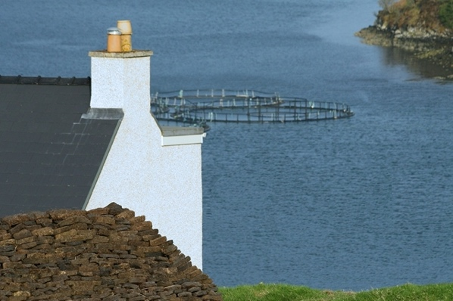

Scientist in the Spotlight

Claire McDonald

*Fish Farm Technician*

Q: How would you describe your job briefly?

A: I am a fish farm technician, or simply, a fish farmer. I work on a sustainable seawater fish farm that looks after and grows Atlantic salmon, which eventually end up in supermarkets and restaurants all over the world.

Q: What does your typical day look like?

A: There are no two days the same, every day is different! But I suppose that is what happens when you work with animals. There are some things that have to be done every day, such as environmental checks (temperature, **salinity**, oxygen content, visibility and plankton checks), feeding the fish, checking the pens for dead fish and removing these, and sample health checks of the fish.

Q: What are some positive aspects of your job?

A: I get to work outside in a beautiful part of the world surrounded by incredible **scenery** and wildlife, including dolphins and whales. I spend very little time sitting in front of a computer screen! The feed conversion ratio for salmon is one of the lowest in animal protein production and my farm is one of the most efficient, which is something I am very passionate about as salmon farming is a sustainable way to use global resources to produce food.

Q: What would you say are the negative aspects of your job?

A: The fish farm that I work on is very exposed, which means that sometimes the weather can be pretty **horrendous**, especially in the winter. We often work in very wet and windy conditions, which is not much fun. When the weather is particularly bad, we cannot even get out to the farm and are stuck on the **shore**.

Q: How did you get into this career?

A: I completed a degree in Sustainable Development at the University of St Andrews before working as an environmental consultant for a large engineering firm, mainly looking at Environmental Impact Assessments. Although this was interesting, I quickly realised that working in an office behind a screen was not for me so I decided I wanted a change. I went back to university to study a master’s degree in Sustainable Aquaculture at the University of Stirling, but also realised there is a lot about fish farming that you cannot learn in the classroom but can learn very quickly on the job! Very few people in the fish farming industry have university degrees, it is more important to be interested in it and passionate about **sustainability**.

Q: What advice would you give to pupils thinking of a career in STEM?

A: Always do what you are most passionate and excited about and do not worry too much about getting the perfect job straight away, because this is actually very rare! The job I am doing now is so different to what I thought I would be doing when I left school but it has been the right path for me. Any work experience that you can get is good experience and you can apply anything you learn to any future job or career.

Activity

Use the scientist’s profile to answer the following questions:

1. What is the scientist’s job?

________________________________________________________________________

________________________________________________________________________

1. Briefly describe what the scientist does in a typical day.

________________________________________________________________________

________________________________________________________________________

1. What skills do they need for this job?

________________________________________________________________________

________________________________________________________________________

1. What do you think is the most interesting part of their job?

________________________________________________________________________

________________________________________________________________________

________________________________________________________________________

1. Describe how this job links with the science you have learned in this unit.

________________________________________________________________________

________________________________________________________________________

1. State the definition of any words in **bold** from the scientist’s answers.

________________________________________________________________________

________________________________________________________________________

________________________________________________________________________

________________________________________________________________________

________________________________________________________________________